Roll No. and Name: 24BTM058 RICHA PATEL
Course Code and Name: 3CS502ME24 OPEN SOURCE TECHNOLOGIES
Practical No: 3
AIM: Database Management with MySQL: Install MySQL and create a database. Perform SQL operations, including table creation, data insertion, and querying.
METHODOLOGY FOLLOWED:

Creating Tables:
CREATE DATABASE restaurant;

USE restaurant;

CREATE TABLE customer ( customerid INT AUTO_INCREMENT PRIMARY KEY, name VARCHAR(100) NOT NULL, email VARCHAR(100) UNIQUE, contactno VARCHAR(10)
);

CREATE TABLE reservation ( reservationid INT AUTO_INCREMENT PRIMARY KEY, customerid INT, reservationdate DATE, reservationtime TIME, guests INT,
FOREIGN KEY (customerid) REFERENCES customer(customerid)
);

CREATE TABLE menu ( itemid INT AUTO_INCREMENT PRIMARY KEY, itemname VARCHAR(100), category VARCHAR(50), price DECIMAL(8,2), availability VARCHAR(20)
);

CREATE TABLE orders ( orderid INT AUTO_INCREMENT PRIMARY KEY,
customerid INT, reservationid INT, orderdate DATE, totalamount DECIMAL(8,2), orderstatus VARCHAR(30),
FOREIGN KEY (customerid) REFERENCES customer(customerid),
FOREIGN KEY (reservationid) REFERENCES reservation(reservationid)
);

CREATE TABLE orderdetails ( orderdetailid INT AUTO_INCREMENT PRIMARY KEY, orderid INT, itemid INT, quantity INT, subtotal DECIMAL(8,2),
FOREIGN KEY (orderid) REFERENCES orders(orderid),
FOREIGN KEY (itemid) REFERENCES menu(itemid)
);
CREATE TABLE payment ( paymentid INT AUTO_INCREMENT PRIMARY KEY, orderid INT UNIQUE, paymentmethod VARCHAR(30), amount DECIMAL(8,2), paymentstatus VARCHAR(20), paymentdate DATE,
FOREIGN KEY (orderid) REFERENCES orders(orderid)
);

Show tables;

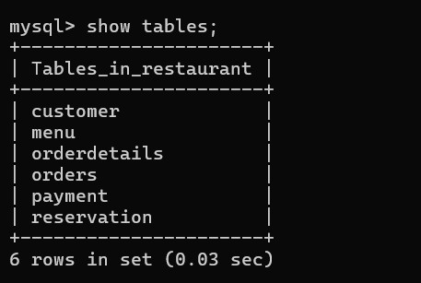

Inserting data :

INSERT INTO customer(name,email,contactno)
VALUES
('vidhi','vidhi@gmail.com','9876543210'),
('rahul','rahul@gmail.com','9876543211'),
('priya','priya@gmail.com','9876543212');

INSERT INTO reservation(customerid,reservationdate,reservationtime,guests)
VALUES (1,'2026-07-30','19:00:00',4),
(2,'2026-07-31','20:00:00',2),
(3,'2026-08-01','18:30:00',5);

INSERT INTO menu(itemname,category,price,availability)
VALUES
('pizza','main course',500,'available'),
('burger','main course',250,'available'),
('pasta','main course',360,'available'),
('sandwich','snacks',140,'available'),
('tacos','snacks',190,'available'),
('french fries','snacks',100,'available'),
('coffee','beverage',190,'available'),
('pastry','dessert',200,'available'),
('chocolate shake','beverage',160,'available'),
('mojito','beverage',140,'available'),
('ice cream','dessert',150,'available');

INSERT INTO orders(customerid,reservationid,orderdate,totalamount,orderstatus)
VALUES
(1,1,'2026-07-30',860,'completed'),
(2,2,'2026-07-31',390,'preparing'),
(3,3,'2026-08-01',700,'pending');

INSERT INTO orderdetails(orderid,itemid,quantity,subtotal)
VALUES
(1,1,1,500),
(1,7,2,360),
(2,2,1,250),
(2,10,1,140),
(3,3,1,360),
(3,8,1,200),
(3,6,1,100);

INSERT INTO payment(orderid,paymentmethod,amount,paymentstatus,paymentdate)
VALUES
(1,'upi',860,'paid','2026-07-30'),
(2,'cash',390,'pending','2026-07-31'),
(3,'credit card',700,'paid','2026-08-01');

Using SELECT:

SELECT * FROM customer;

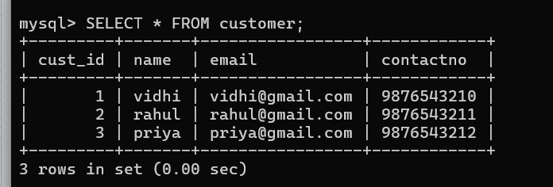

SELECT * FROM reservation;
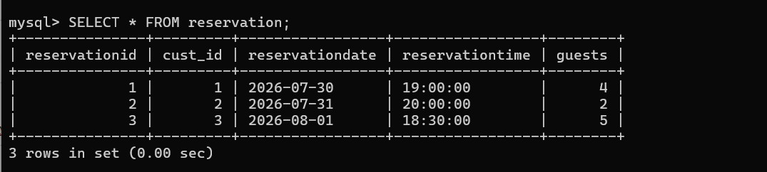

SELECT * FROM menu;
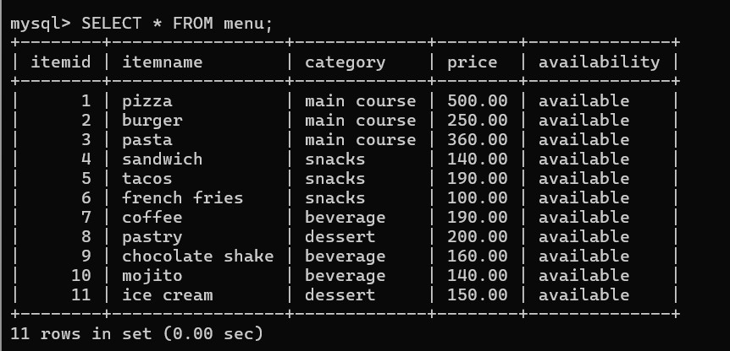

SELECT * FROM orders;
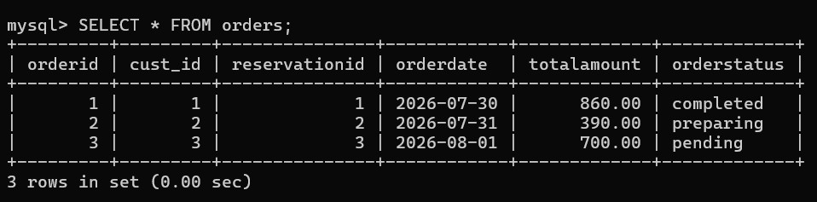

SELECT * FROM payment;
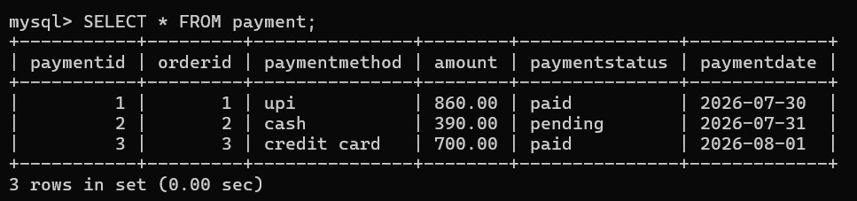

Using WHERE:

SELECT * FROM menu
WHERE price > 200;
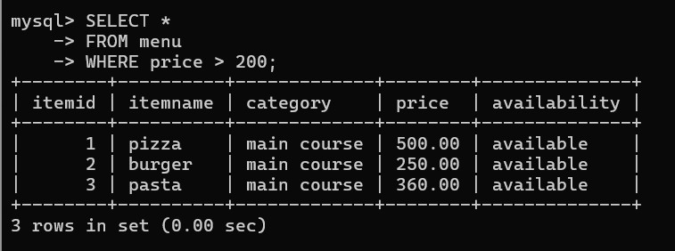

Using ORDER BY:

SELECT * FROM menu
ORDER BY price DESC;

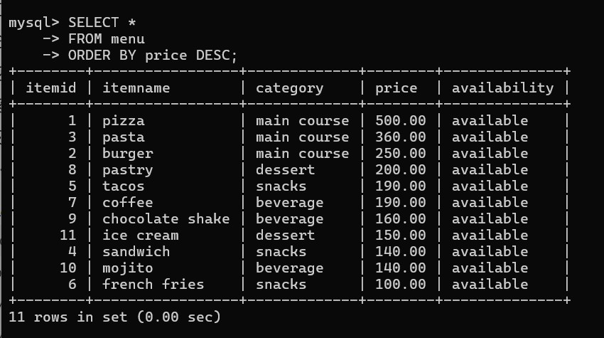

Aggregate functions:
SELECT COUNT(*)
AS totalcustomers
FROM customer;

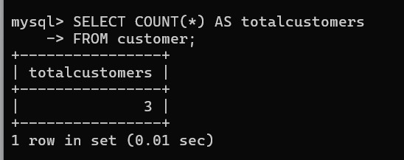

SELECT SUM(amount) AS totalsales
FROM payment
WHERE paymentstatus='paid';

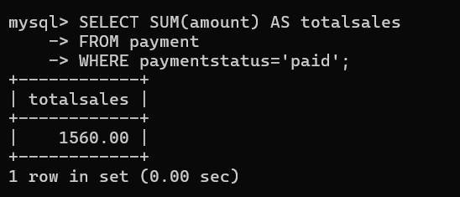

SELECT AVG(price)
AS averageprice
FROM menu;

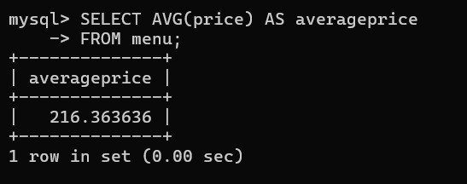

JOIN:
SELECT customer.name, reservation.reservationdate, reservation.reservationtime, reservation.guests
FROM customer
INNER JOIN reservation
ON customer.customerid = reservation.customerid;

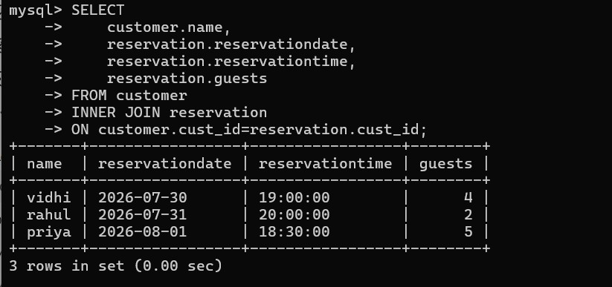

SELECT customer.name, orders.orderid, orders.totalamount, orders.orderstatus
FROM customer
INNER JOIN orders
ON customer.customerid = orders.customerid;

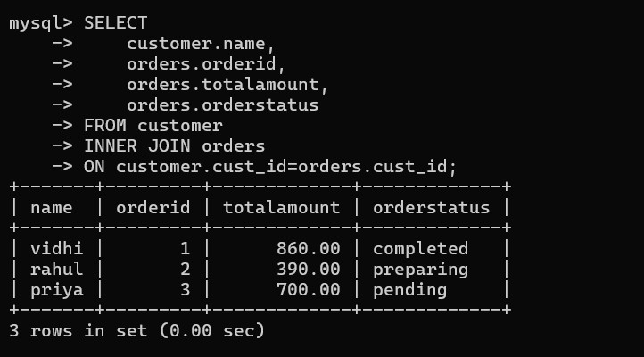

UPDATE:
UPDATE menu
SET price = 550
WHERE itemid = 1;

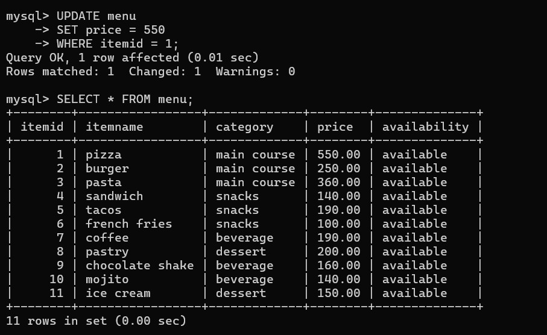

UPDATE customer
SET contactno='9999999999'
WHERE customerid=1;

SELECT * FROM customer;
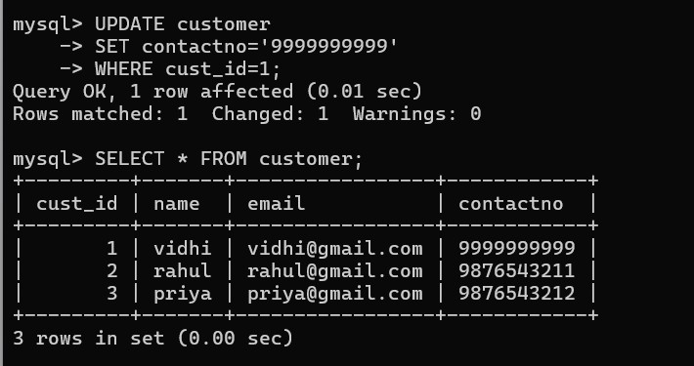

UPDATE orders
SET orderstatus='completed'
WHERE orderid=2;

SELECT * FROM orders;
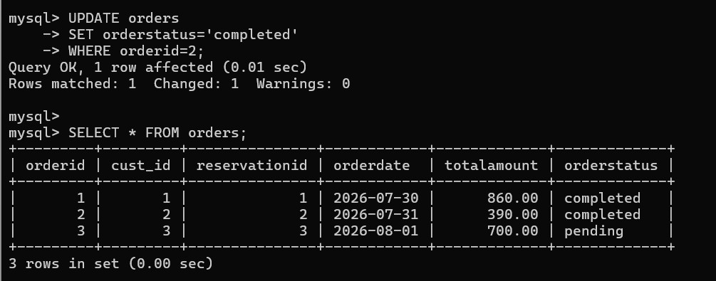

Using DELETE:

DELETE FROM payment
WHERE paymentid = 2;

SELECT * FROM payment;

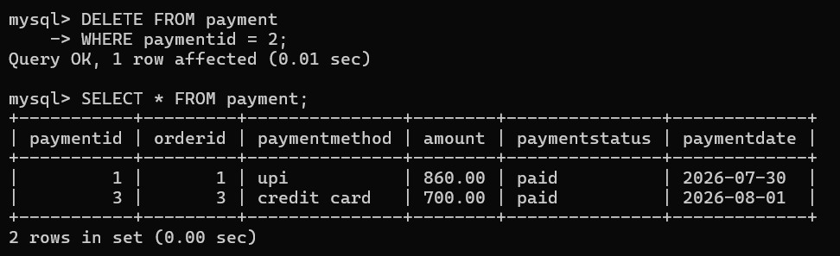

Using ALTER TABLE:

ALTER TABLE customer
ADD address VARCHAR(100);

SELECT * FROM customer;
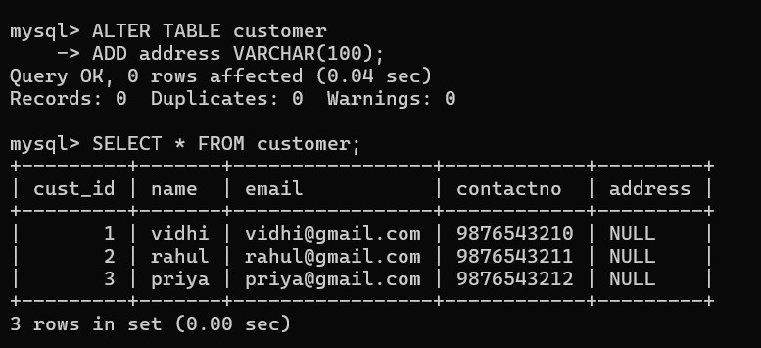

ALTER TABLE customer
DROP COLUMN address;

SELECT * FROM customer;

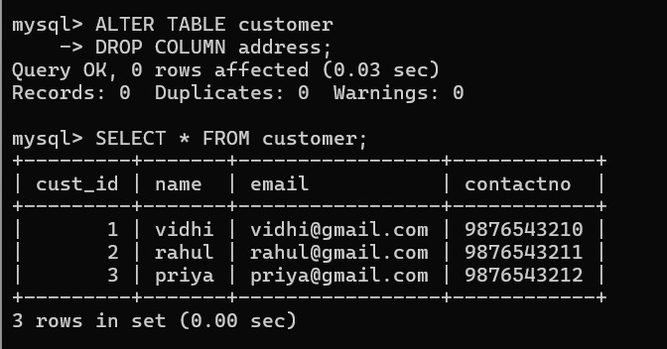

Using GROUP BY:

SELECT category, COUNT(*) AS total_items
FROM menu
GROUP BY category;

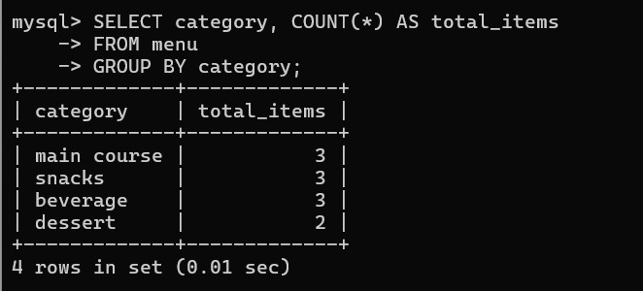

SELECT category, AVG(price) AS average_price
FROM menu
GROUP BY category;

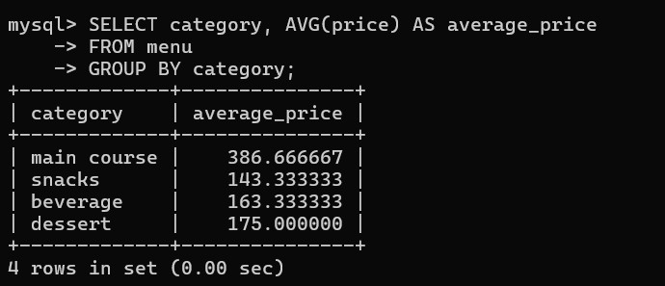

SELECT paymentmethod, SUM(amount) AS total_amount
FROM payment
GROUP BY paymentmethod;

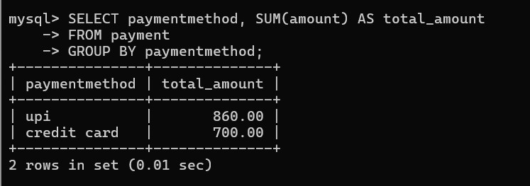

USING HAVING:
SELECT category, AVG(price) AS average_price
FROM menu
GROUP BY category
HAVING AVG(price) > 180;
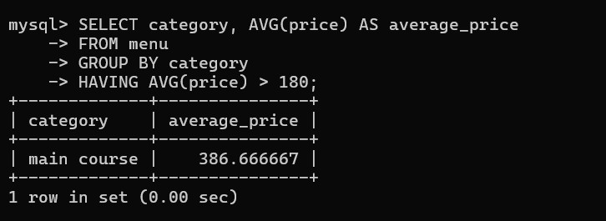

SELECT paymentmethod, SUM(amount) AS total_amount
FROM payment
GROUP BY paymentmethod
HAVING SUM(amount) > 500;

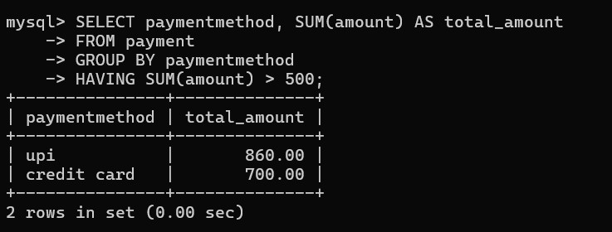

Using DISTINCT:

SELECT DISTINCT category
FROM menu;

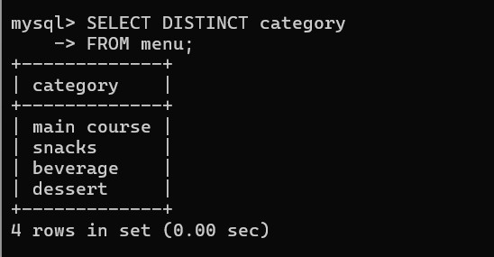

LIKE:
SELECT * FROM menu
WHERE itemname LIKE '%a';

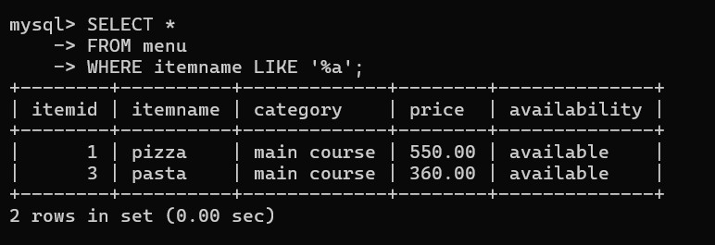

SELECT * FROM menu
WHERE itemname LIKE '%e%';

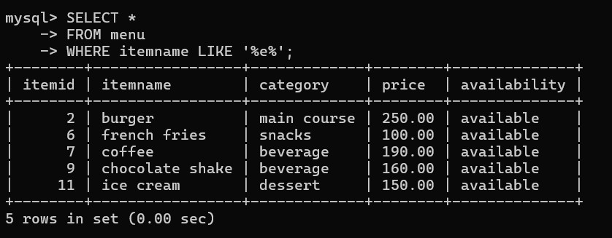

Using IS NULL:

SELECT * FROM customer
WHERE email IS NULL;


OR:
SELECT * FROM menu
WHERE category='dessert' OR category='beverage';
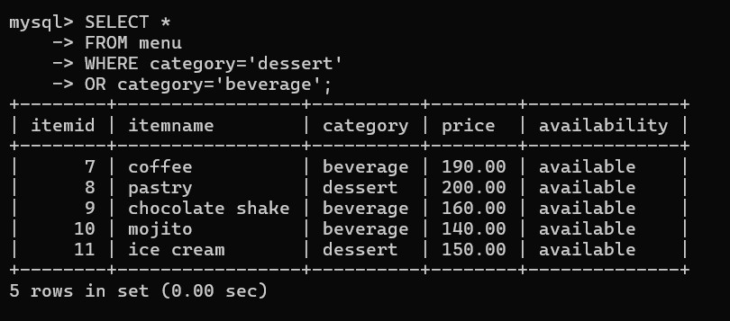

Using ROUND:

SELECT ROUND(AVG(price),2)
FROM menu;
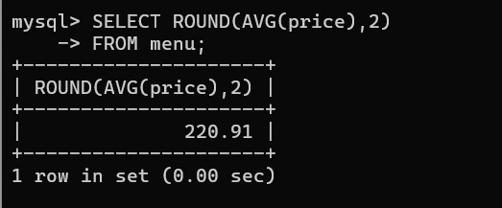

Using BETWEEN:

SELECT * FROM menu
WHERE price BETWEEN 150 AND 300;

